

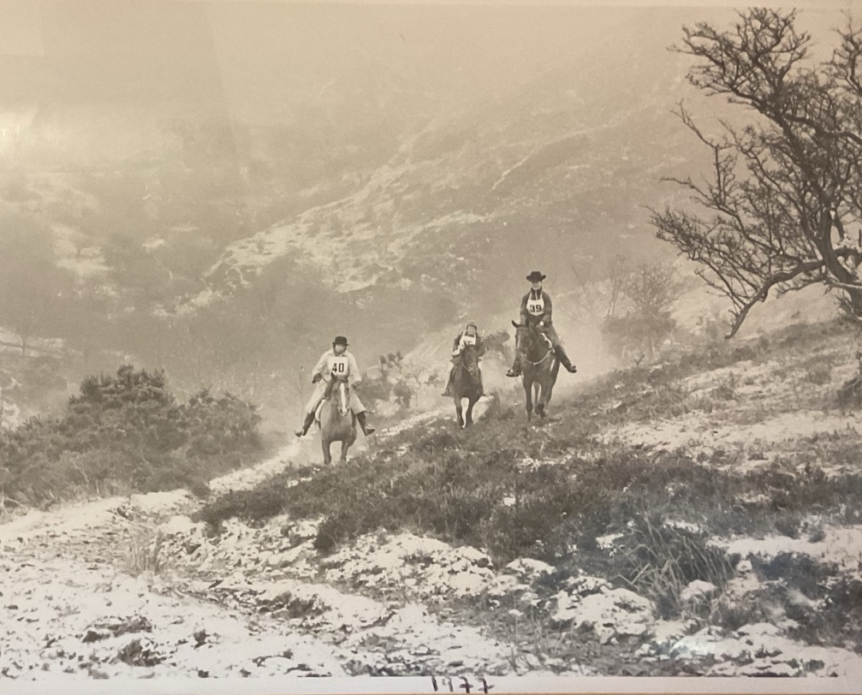

The 57th Golden Horseshoe Ride

24th – 25th May 2025
60th Anniversary Year

A Tribute

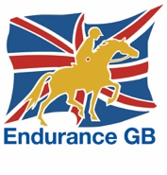
Treborough, Ellicombe and Exford

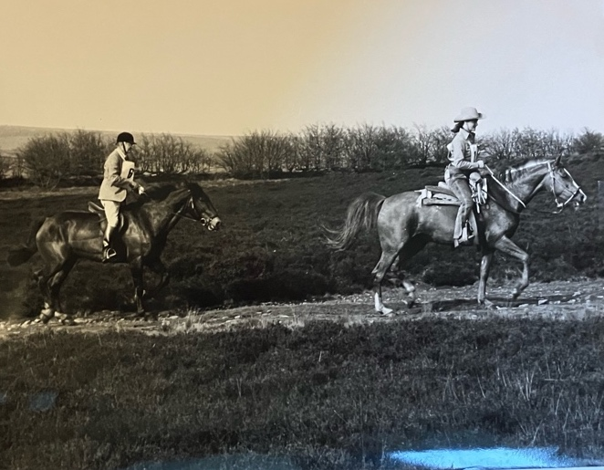
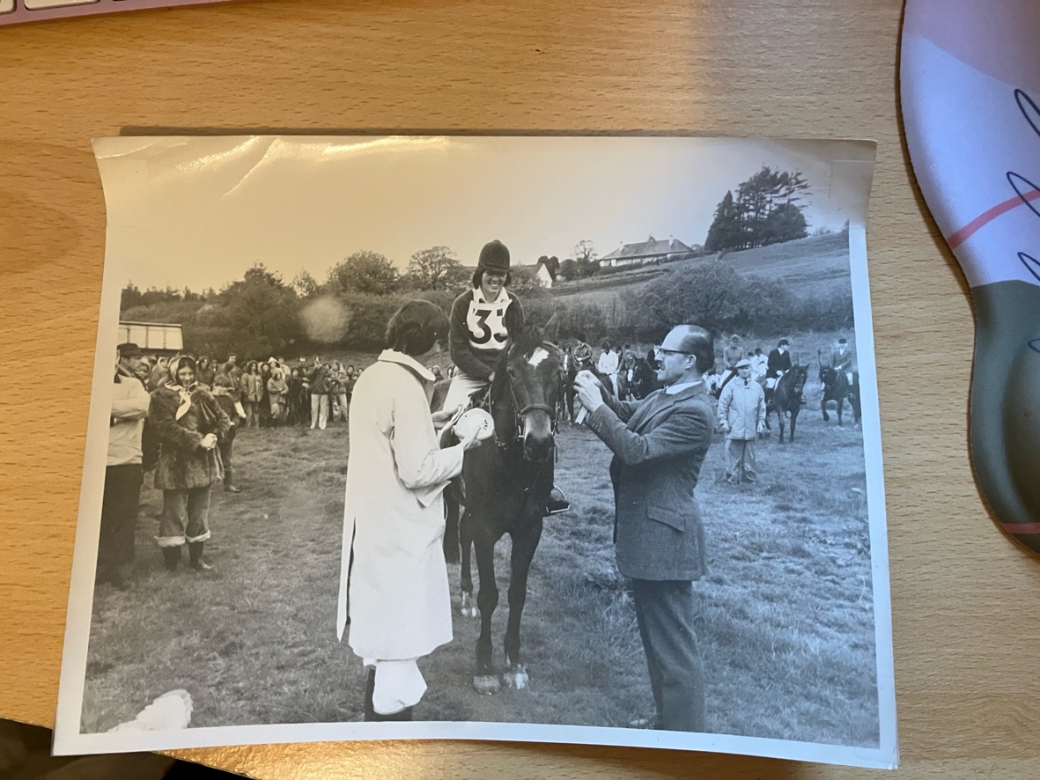
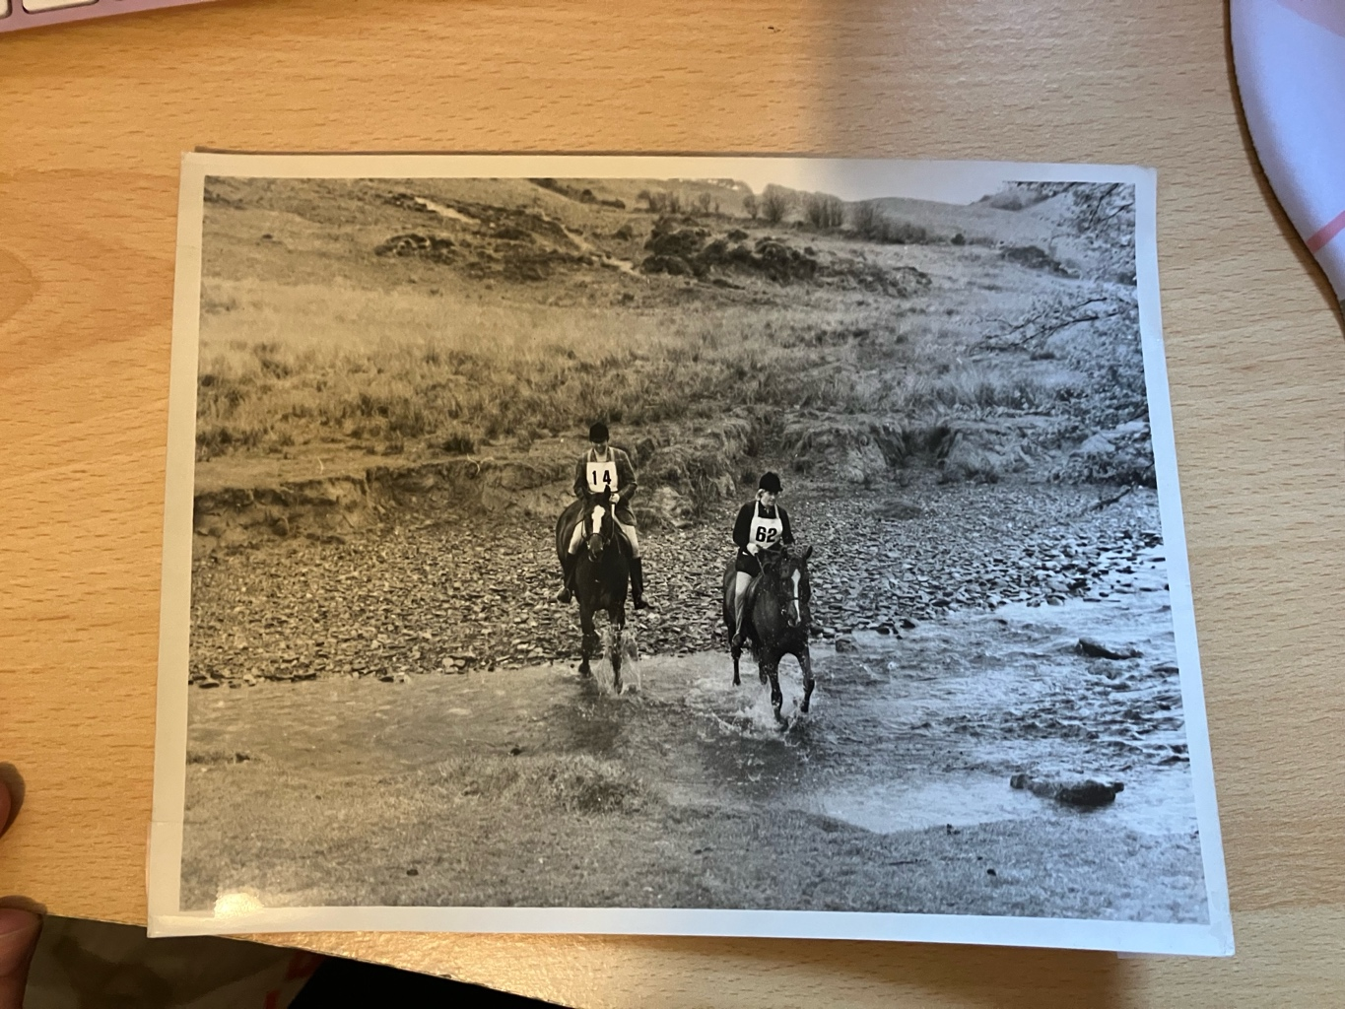
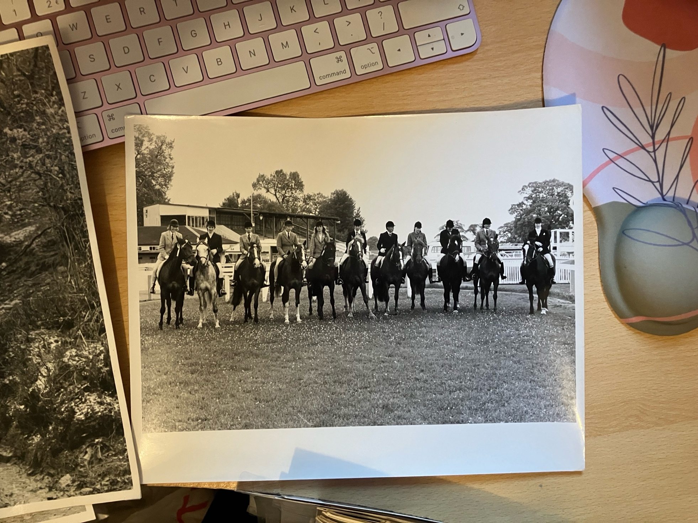
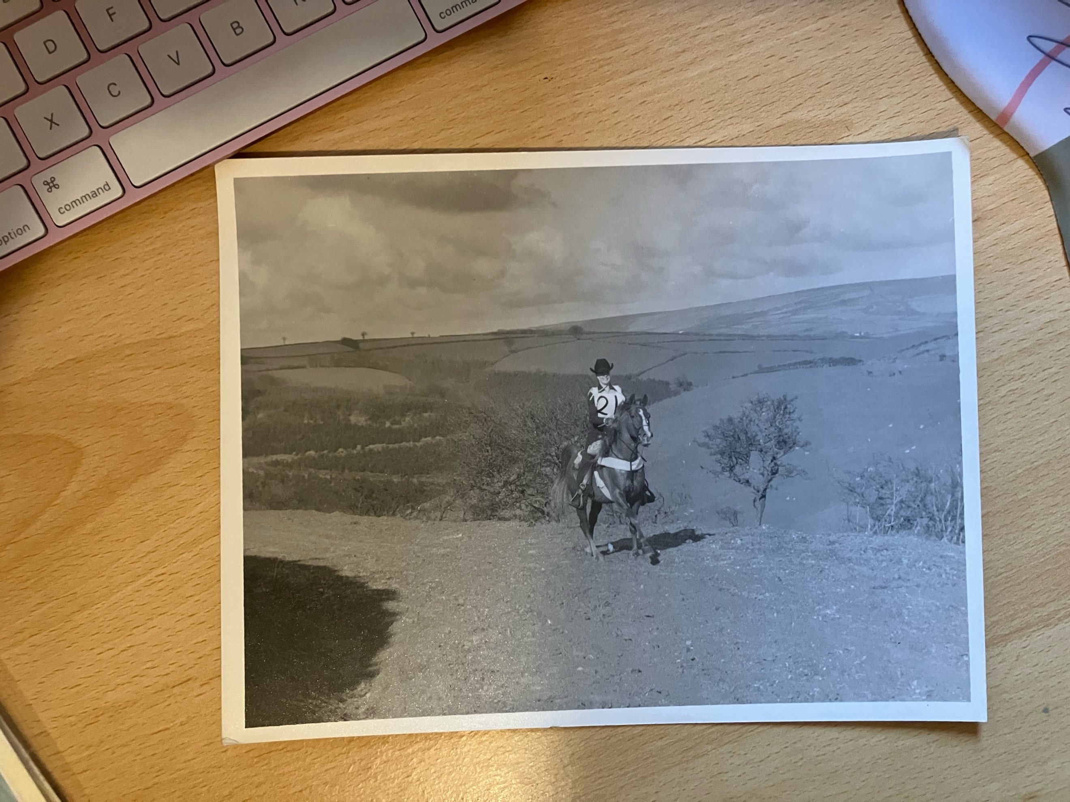
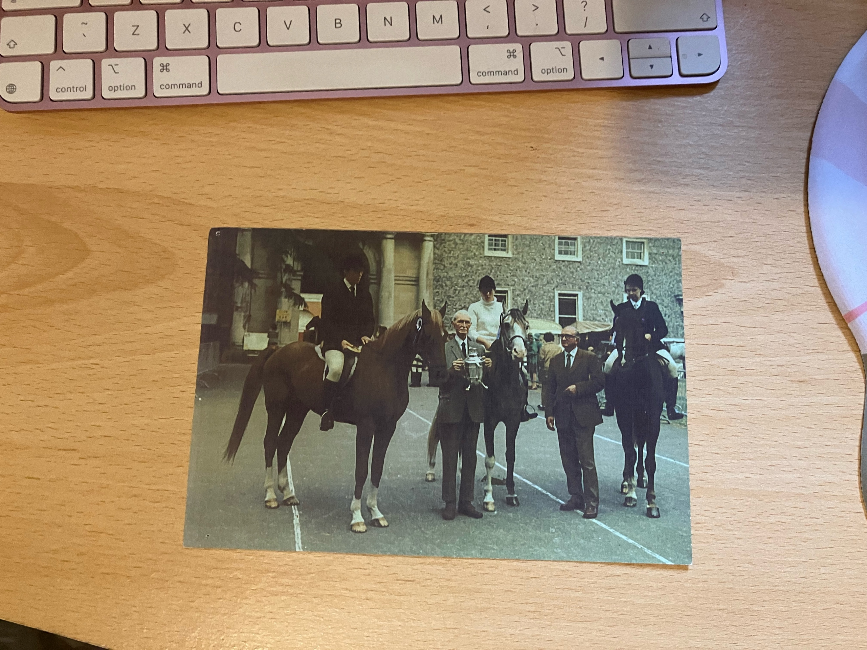
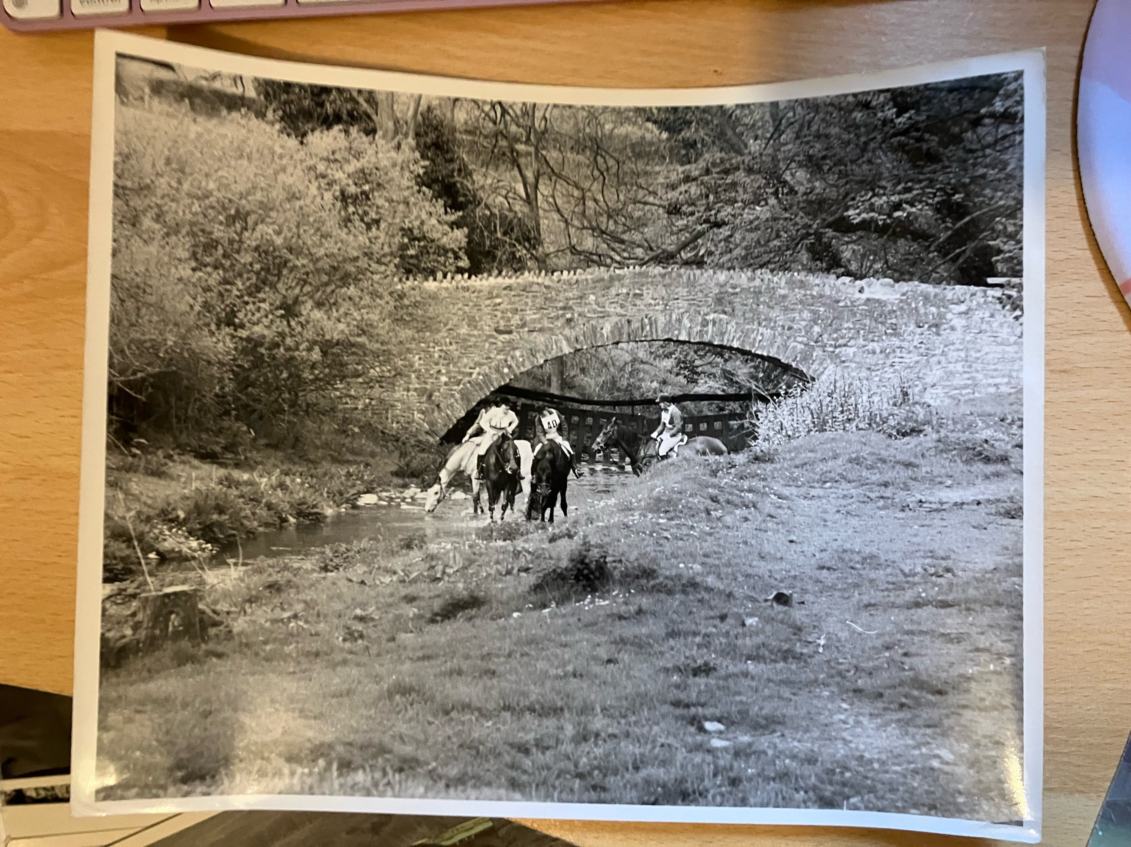
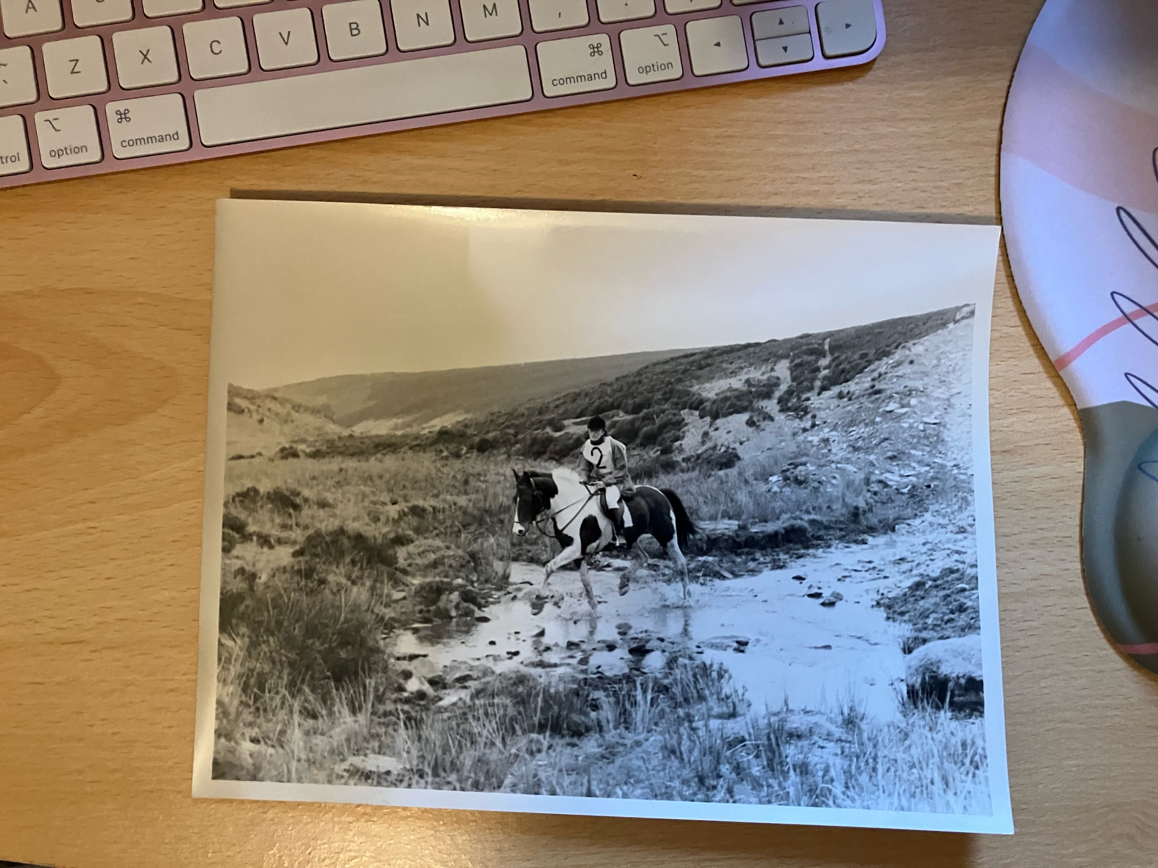
Welcome
In 1965 two great friends came together with an idea to test the “knowledge and fitness of riders and encouraging the better conditioning and care of horses” by establishing a long-distance ride, in the spirit of the Tevis Cup which had recently started in America.

Colonel Michael Picton Ansell was appointed Companion of the Distinguished Service Order in 1944 but was shortly after was wounded in the hand and eyes by ‘friendly’ fire, blinding him permanently and he lost all 4 fingers on his left hand. Not only that but he became a Prisoner of War too. Despite these trials he made it home and was a staunch supporter of equestrian disciplines. The Golden Horseshoe Ride is probably one of his lesser-known achievements – he is more readily associated with the Horse of The Year Show which celebrated its 75th anniversary this year.

Ronald Duncan was South African born but moved to London with his family during World War One. He eventually made his home in North Devon and was known as a farmer, horse breeder and most importantly, a poet. Most equestrians know him for the poem ‘The Horse’ which was written at Col Ansell’s request for the Horse of the Year Show. It has become an anthem for the UK Endurance world too…being read at the beginning of each Gala Dinner night. Every horseperson can relate to the evocative images the poem provokes.

These two men came together and persuaded the British Horse Society and the Sunday Telegraph to get behind a 50-mile ride from Malmesmead to Duncan’s home at Welcombe in Devon. This route crossed moorland and followed roads and tracks. It was so popular, entries reached capacity at over 100 and had to close several weeks early. Horse transport wasn’t as easy as it is now, with some coming by train or by hacking great distances (from Surrey for example) just to get to the start line!

The first ride rules were simple; complete the 50 miles, pass the vet check and go at least 7.5mph to get a Gold Award – so many people got a gold award some had to wait for additional trophies to be made. Anyone going slower were given a bronze horseshoe. There was no minimum speed.

We had hoped to recreate that original route but unfortunately there are housing estates in the way and the CPs are in what would now be considered dangerous road junctions. Instead, our team of Amanda Hamley, Jo Woodman and Neil Arnold have devised a 50-mile route from Treborough, winding to Ellicombe for a halfway vetting and onto the Exford Showground to finish. This is the 2025 Golden Horseshoe Ride – a one-day 50-mile (or 80km) ride like the original. We have some support classes on both days for those that still want to be part of this very special occasion.

To still be going strong with only 3 years missed (change of Ride Organiser and COVID) is something very special…we hope we can get it to its 70th birthday!

For those taking part – please take a moment to reflect on this wonderful example of Endurance – not only the ridden aspect, but the commitment of those past and present who have kept this ride as a firm favourite on the calendar. And we, the organising team, thank each and every one of you for being here to keep that spirit alive.
Enjoy the trail!
Event Programme
(correct at time of going to print)

Friday 23rd May 25

1500hrs – Arrival for those corralling at Treborough
1600hrs – Ride Office opens at Treborough
1700hrs – Vetting for Golden Horseshoe and Stag Classes at Treborough venue
1800hrs – Briefing for all in Stag and Golden Horseshoe Class. Golden Clench riders welcome
1900hrs – Latest arrival – please call if you are going to be late

Saturday 24th May 25

0730 – Ride office opens at Treborough
0830 – 0845hrs – All competitors in Golden Horseshoe and Stag Class to start at Treborough.
(this is a change to previous years – the original Golden Horseshoe Ride had a mass start of 35-35 horses per 15-minute window).
1000hrs – Ride office opens at Ellicombe
1100hrs – Vetting starts for 40km competitors at Ellicombe
1130hrs – First arrivals to Ellicombe for mid-way vetting expected
1130 – 1200hrs – 40km Riders to start at Ellicombe
1400hrs – Ride office opens at Exford
1500hrs – Dog Show starts at Exford Showground
1500hrs – First riders due at Exford Showground
1800hrs – Prize Giving for Golden Horseshoe Class (including those riding in the Stag) and Moor to Mountain Challenge with Dinner at Exford Showground
2000hrs – All to depart Exford Showground

Sunday 25th May 25 – all at Exford Showground

0800hrs – Ride office opens
0845hrs – Vetting for Stag
0900hrs – Vetting for Otter and Otter Cub starts
0915hrs – Stag starts
0930hrs – Otter and Otter Cub classes start
1000hrs – Trot ups for Bambi and Fawn
1030hrs – Bambi and Fawn classes start
1100hrs – No further starters
1230hrs – Riders start to return to venue
1700hrs – Prizegiving (all other classes) and Dinner
1900hrs – All to depart

Monday 26th May 25

NLT 1000hrs – all those camping and corralling to depart.

Ride Officials

Organisers: Maggie Pattinson / Amanda Hamley

Route: Amanda Hamley / Jo Woodman / Neil Arnold

Ground Jury: Maggie Pattinson / Stephen Blackwell / Sarah Coombes

Technical Steward: Shelley Bates

Health and Safety: Stephen Blackwell

Veterinary Surgeons: Jo Woodman MA VetMB MRCVS (Chief Vet)/ Sarah Coombes / BVetMed Bsc MRCVS / Paul Jarvis BVSc MRCVS (treatment vet) / Kieran O’Brien MVB PhD MA MRCVS

Farriers: Ryan Easterbrook DipWCF
Kieran Smale DipWCF

Vet Steward: Della Short

Timekeeper: Lynn Searle and Cherrie Houghton

Ride Secretary: Georgina Rolls

Medical Cover: Ash McKiernan – Absolute Safety Training

Catering: Atlantic Grill and Crepes Galore

Route Marking: Neil Arnold and his team of trail bike riders
Mike and Irene Farmer

Photographer: David Saunders

Vet Writers: Claire Sedgewick / Tim Smith / Millie Ellis / Jo Chisholm

And we of course want to say a huge thank you to all those selfless helpers who
have come to open gates, stand on Checkpoints or road crossings and be there
just to make sure the day goes smoothly! We couldn’t do it without you!

The Golden Horseshoe Ride 2025 - Classes

Class 1 – The Golden Horseshoe

A ride of 80km (50 mile) over a linear route. This is a special class to celebrate 60 years since
the inception of the Golden Horseshoe Ride

Class 2 – The Golden Clench

A ride of 40km over a linear route starting at the vet gate for Class 1. Open to
Open and Advanced combinations only

Class 3 – The Golden Team Event

An opportunity to ride as a relay team over the 80km linear route. No-one has
opted to complete this class

Class 4 – The Exmoor Stag

A ride of 120km over two days; Day 1 follows the 80km linear route and entrants
will be eligible for the Golden Horseshoe prizes. Day 2 follows a 40km circular
route from Exford Showground

Class 5 – The Otter

A ride of 40km over a circular route for Open and Advanced combinations

Class 6 – The Otter Cub

A ride of 40km over a circular route for Novice combinations

Class 7 – Bambi

A ride of 25km over a circular route open to everyone

Class 8 – Fawn

A ride of 16km over a circular route open to everyone

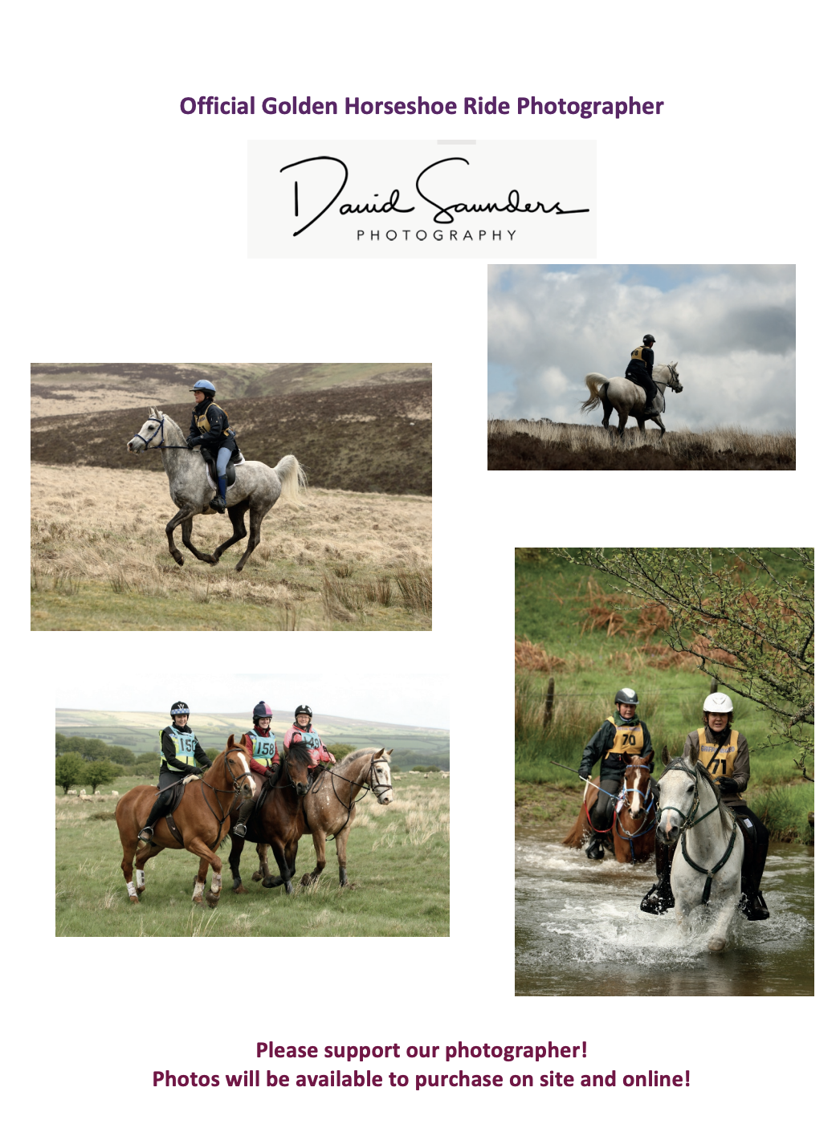
Awards

All competitive classes will be scored according to the Golden Horseshoe Ride
Criteria. Successful combinations will be awarded GOLD, SILVER, BRONZE or
COMPLETION in line with their average speed:

- Gold 12kph or over
- Silver 10.5kph or over
- Bronze 9.5kph or over
- Completion 8/9kph depending on level

Minimum speed for completion for Open/Advanced classes is 9kph and for the Novice class 8kph and this must be maintained each day.

If you are doing a multi-day ride and are below the minimum speed on day one you will be eliminated. You cannot be awarded a higher award than what you finish with on the first day of the class.

Penalty Points

The first heart rate reading (i.e. before the trot up) taken at the end of the class or each day for multiday classes, will be used as the basis for the awarding of penalty points. Penalty points may be incurred for heart rate only.

- Heart rate of 58 or less – no penalty
- Heart rate of 59 – 64 – one penalty
- Heart rate of 65 or more – elimination

A penalty drops the overall award by one place (e.g. Gold to Silver)

Endurance GB Trophy Points

As grade are not used for the GHR, trophy points are awarded as follows:

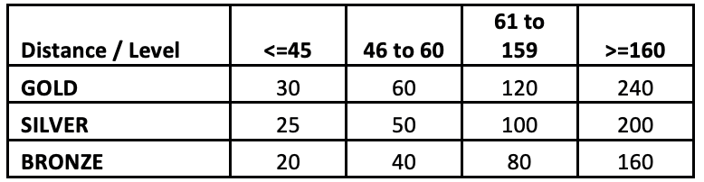

These are added to your distance points.
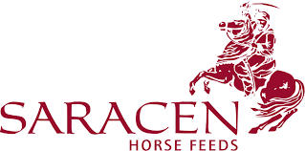

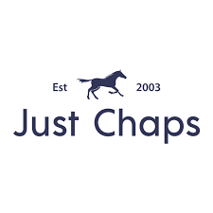



Dee’s Designs
With thanks for permissions, concessions or prizes to:

65 Landowners contacted





The Margaret Evans Memorial Trophy
This trophy has very kindly been donated for the 60th Anniversary year of the Golden Horseshoe Ride for the winner of the 80km class, which this year has been set as a linear route to most closely recreate the ride as it was in its original form.
The trophy is the one of the original trophies won by Margaret Evan’s Russian Arab stallions LISTOPAD (Pomeranets/Laba) and NAPLYV (Pomeranets/Nitochka). They were ridden in the inaugural 1965 Golden Horseshoe Ride by herself and her stud groom Bill Pettigrew respectively and both gained Gold Awards.
Margaret was a stalwart of the Arab Horse Society and breeding was her passion, initially using Crabbet Arabians and standing at stud, amongst others KAMI (Iridos/Kabara), bred by Miss Gladys Yule. She also loved racing and was a steward for many years at AHS races.
Margaret passed away in 2009 and her trophies were passed into the care of Diana Whittome, who was another hugely respected Arabian breeder and an integral part of the AHS for many years. In honour of her many years of service to both the Arabian horse and AHS Diana was the first ever recipient of the AHS Lifetime Achievement Award in 2023.
Diana sadly passed away last year and care of the trophies passed to her sister Libby Whittome who kindly brought this trophy down to Exmoor recently to donate for award at this year’s ride. Libby is herself a breeder of Arabian horses but also competed to top level in endurance rides, including the Golden Horseshoe and also the very first one day 100mile event run by the EHPS.
Sadly with a mare due to foal and living up in Scotland Libby is unable to be here herself to present the trophy on behalf of her sister. However, she very much felt that in this Anniversary year particularly it was important that the trophy continues to be awarded to endurance riders who successfully compete with their horses for 80km over Exmoor.
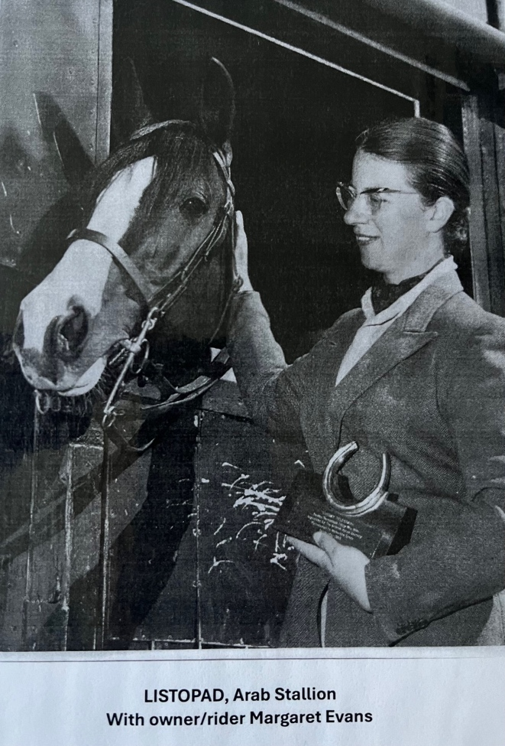
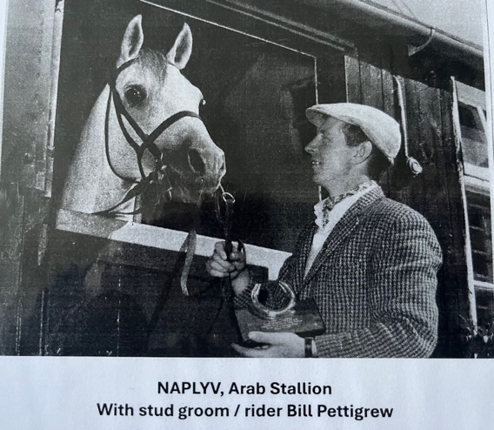
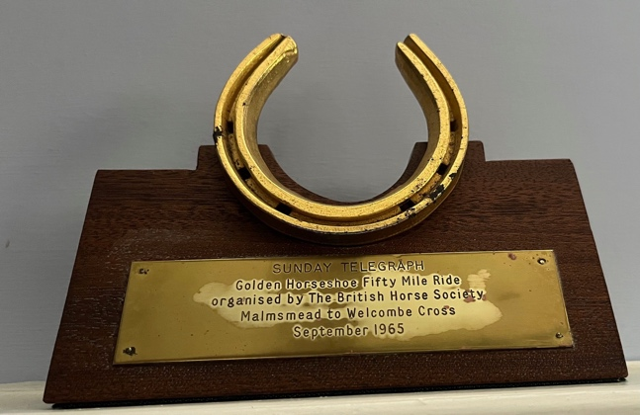

LONG MYND & DISTRICT BRIDLEWAYS ASSOCIATION wishes the very best of luck and safe travels to Katy Mellor riding Quantock Phoenix, a hill horse born and bred. Quantock Phoenix joins the list of great horses trained for Golden Horseshoe on the wild uplands of the Long Mynd in Shropshire. A brand-new library of trails, The Pathfinder Project, has been created and published by Katy to give riders even more incentive to explore the Shropshire Hills.
LMDBA winners of the British Horse Society Equine Access Group Award 2020/21 www.lmdba.co.uk
The Pathfinder Project Facebook Instagram TikTok
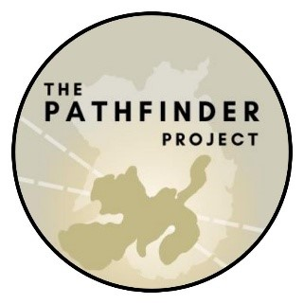
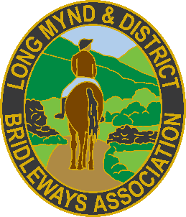

Good Luck to Katy Mellor and Phoenix
from all your friends and family.
Quantock Phoenix born & bred on the Quantock Hills was gifted to Katy at weaning by her Granny Janet. Rob White and family from Durboro Farm, Aisholt wish Katy and Phoenix every success in the 80km GH Class.
Rob will have 2025 Quantock Foals sired by Sir Lancelot for sale at weaning in the autumn. Contact Rob on 07864107048 rjewhite@icloud.com or Sally Mellor via FB Messenger sallymellor@hotmail.co.uk.

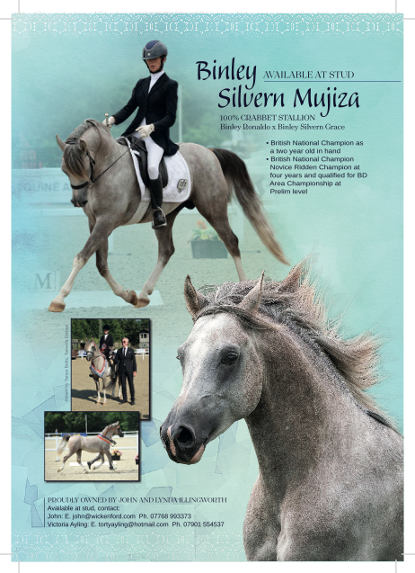
A Golden piece of history…
We thought we would look back at a previous Ride Organiser to bring you some history of the Golden Horseshoe and who better than the lady who saw the Golden Horseshoe Ride to it’s 50th Anniversary. 10 years on we are honoured that Barbara and Ian are still involved with the Golden Horseshoe Ride and look forward to seeing them over this weekend….
We bet you didn’t know some of the gems in this story!
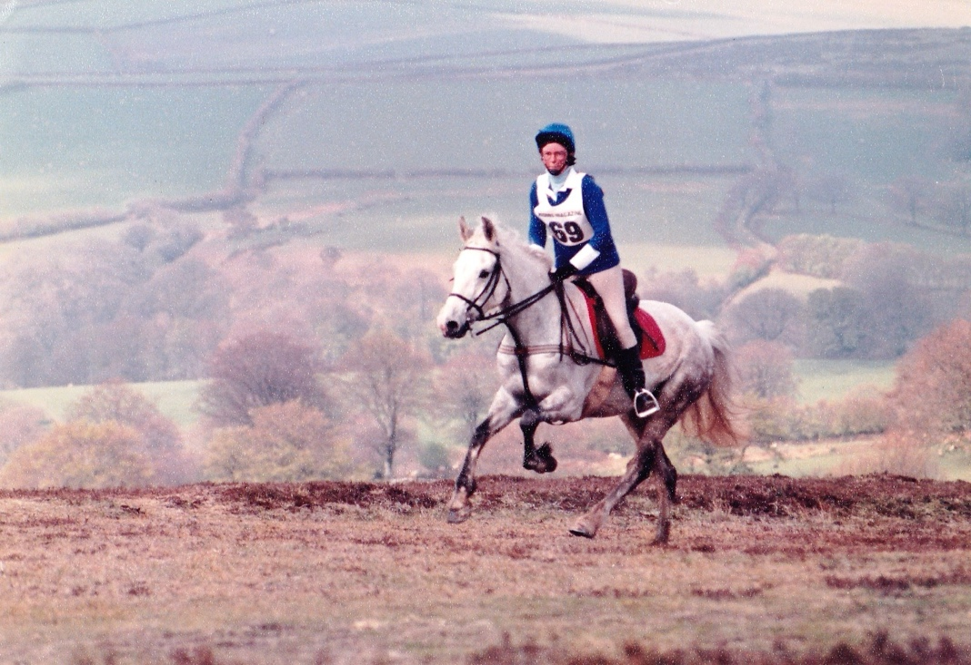
Barbara started endurance (or long-distance riding as it was called then) back in 1984 and attended the Golden Horseshoe for the first time in the same year. The following year she returned and was awarded a Gold award with her first horse Shushumi.

She continued competing herself, as well as crewing daughter Nic, through the 80s, 90s and into the early 00s, returning to the Horseshoe virtually every year as either competitor, crew or spectator.
Of her many major achievements Barbara competed in multiple major rides the length and breadth of the country, and came 7th out of a large class, at the Summer Solstice in 1988 at Hexham.

She was also a team selector for Team GB!

She bred two endurance horses from Shushumi - El Shurim and Dazzler's Mischief - successfully competing both, and in 1996 she rode for several days with Bob Champion on his Ride for Life, joining the finale of the ride to parade down The Mall and meet the Queen in the Royal Mews.
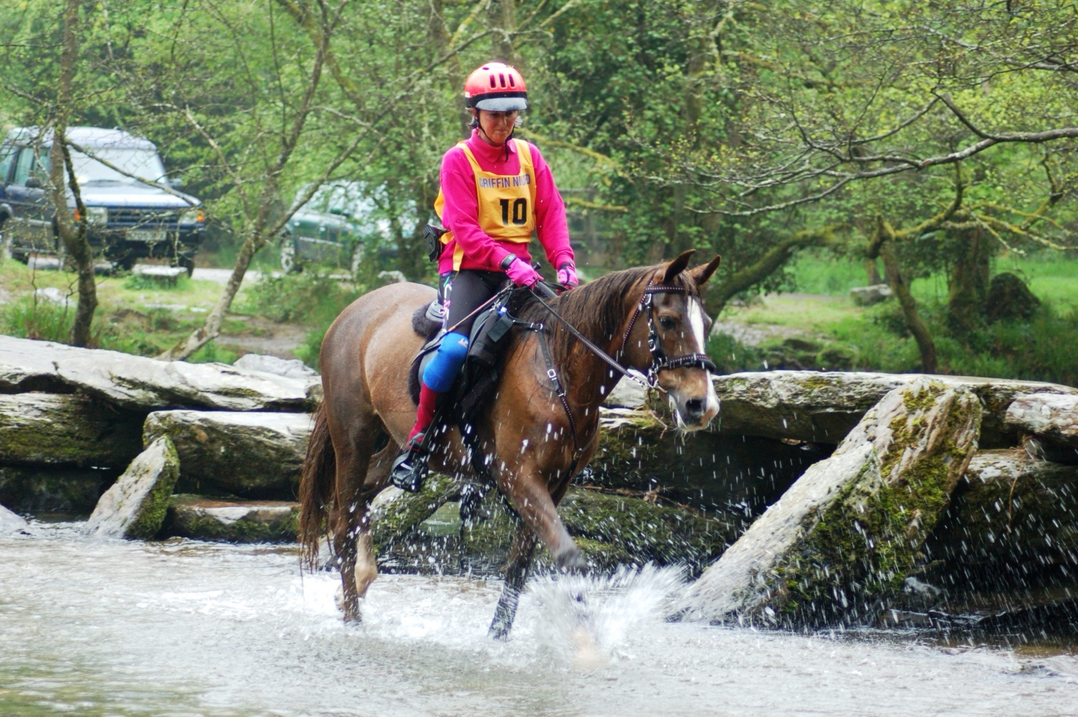
Barbara loved The Golden Horseshoe, with its varied terrain and beautiful landscape. The pull of Exmoor was so strong, that in 2003 she realised her dream of moving to live there. Her new horse Bletsoe Royal Marie achieved a Gold in the Exmoor Stag in 2004, and a Silver in the Horseshoe class in 2006, before Barbara moved from competing to organising, taking over running the Golden Horseshoe from 2007, up to the 50th anniversary in 2015. During this time Barbara became rather well known locally, with anyone who is anyone knowing her, and landowners still ask after her to this day.

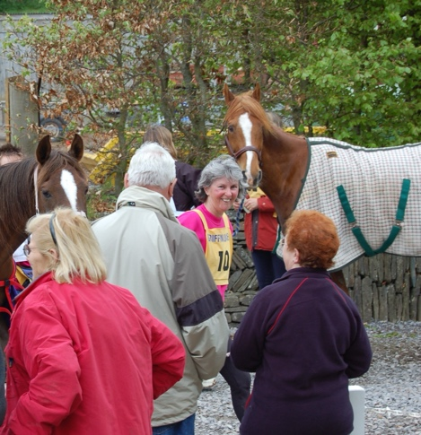 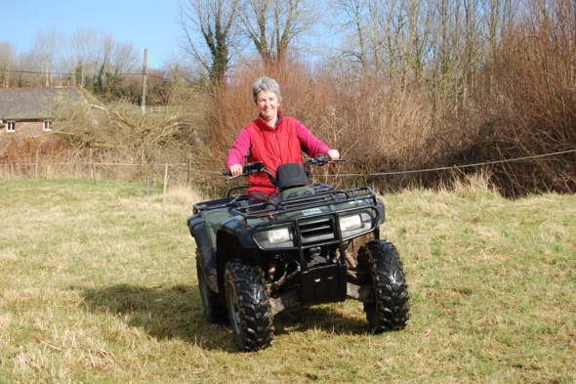
She is now looking forward to supporting the event on its incredible 60th Anniversary, so do wave and say hello to her if you see her out and about at the venue.

Barbara Wigley
Multiple Golden Horseshoe competitor, Team GB Selector, Local Legend!

Enjoy the ride, enjoy the challenge.
To finish really is to win but just to take part makes you a winner.
Trot on!
Sally (and Mike) from the days of Border Trails Endurance

The Bere Horsewatch Riding Club wishes all the competitors the very best of luck and says a HUGE THANK YOU to the GHR organisers, the land owners and the many helpers.

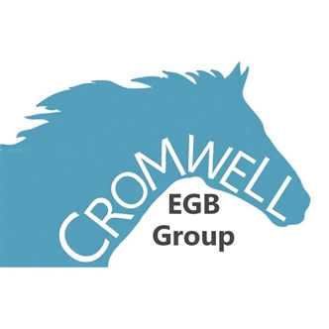
Good luck to all the Cromwell members competing at the GHR!

Pollendine Builders would like to send their best wishes and good luck for a wonderful GHR 40km ride to:
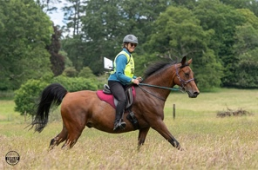
Janthea Newman on The Enigmatic Mr James Bond
And
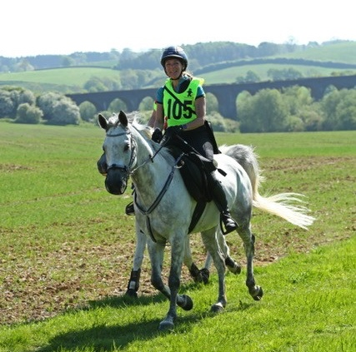
Jaime Snell-Pollendine on Hassmar de la Fichade.
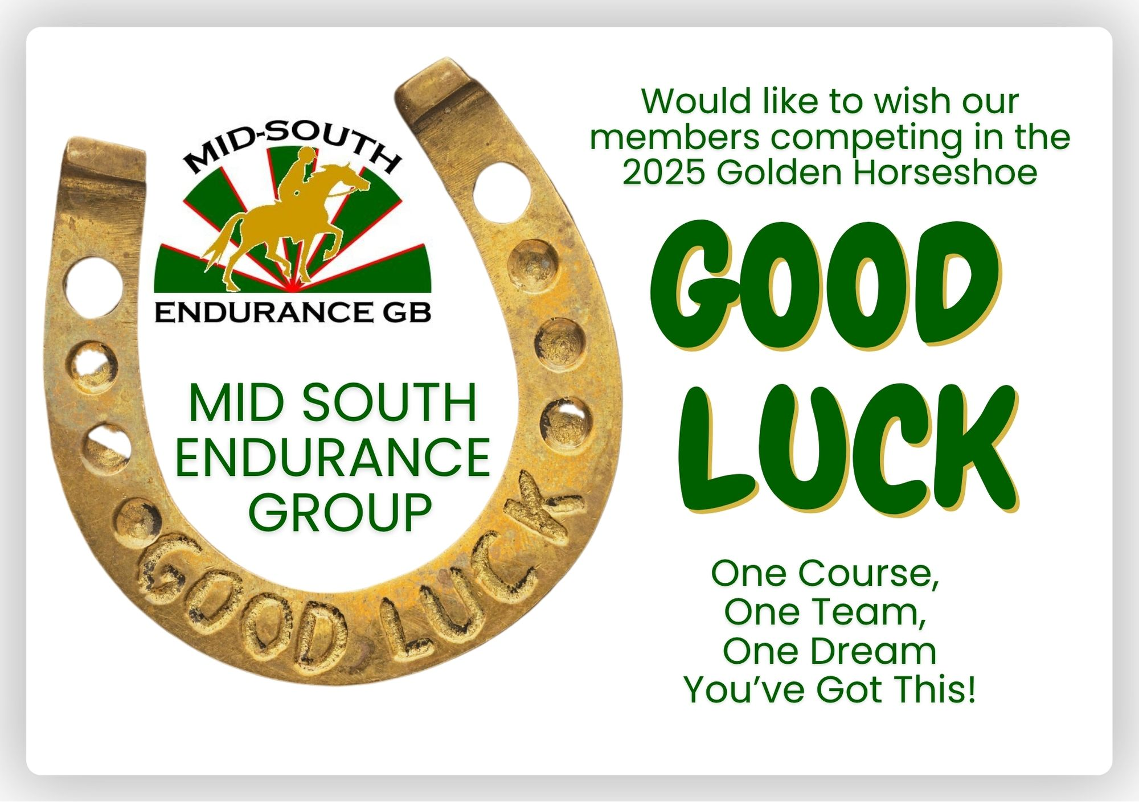
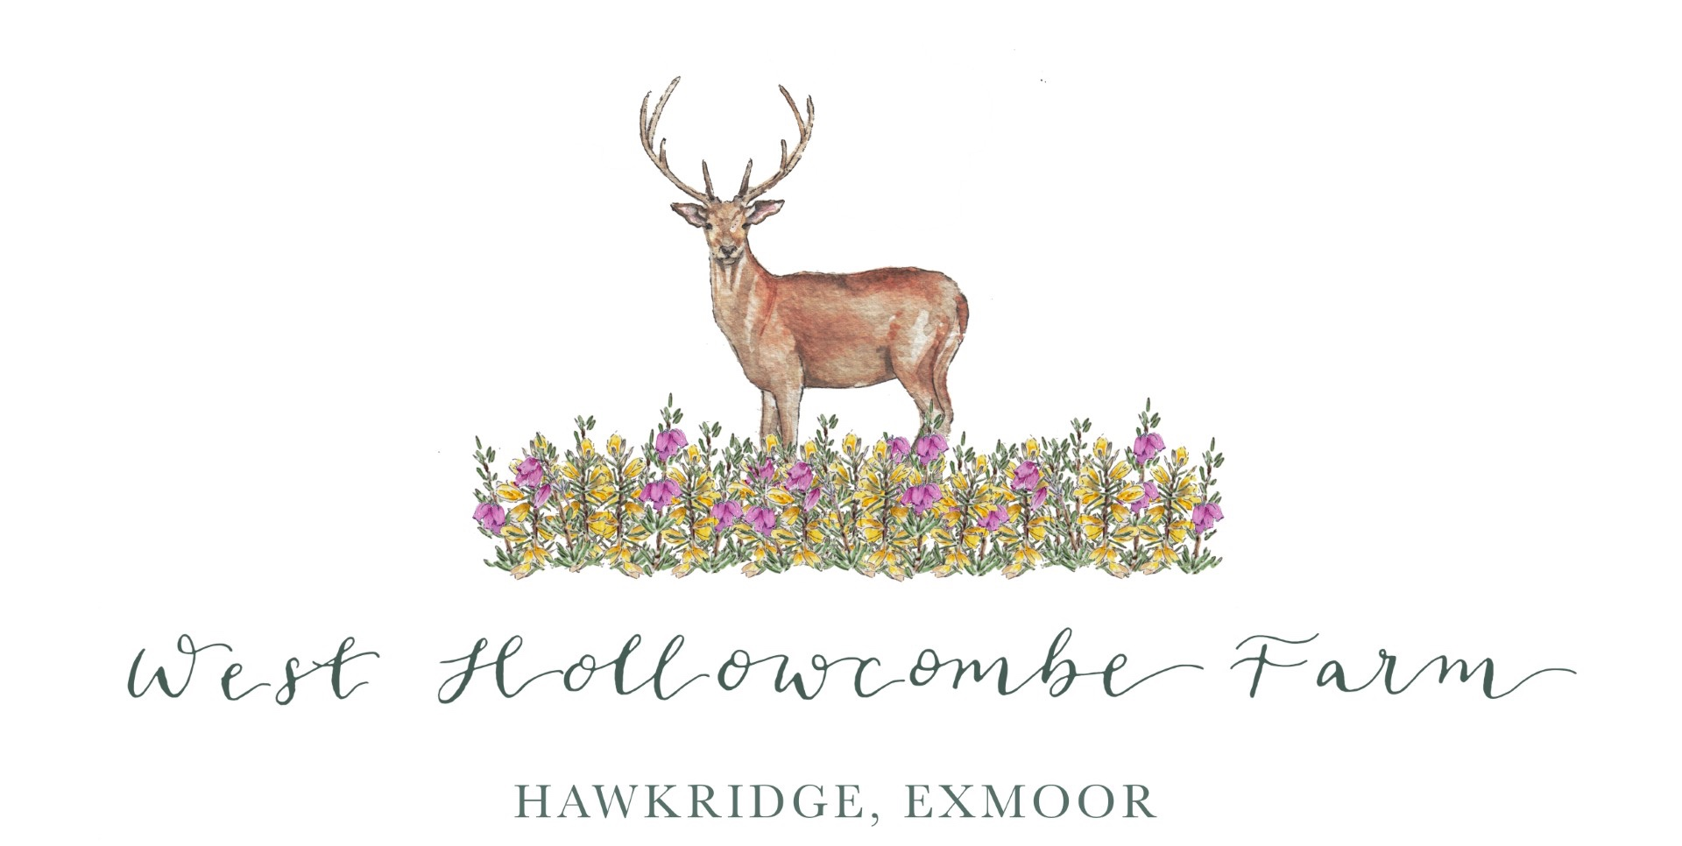
"Proud to support the Golden Horseshoe Ride"
From West Hollowcombe Farm www.westhollowcombe.co.uk — offering characterful self-catering stays and unforgettable horseback holidays, all set in a spectacular Exmoor location with breathtaking views. The perfect base to explore, ride, and unwind.

Awards
(These may be subject to change in the event due to entries)
Special Awards
Multiple Classes:
THE FANCY THAT TROPHY– presented by Tracy Thompson to the highest placed rider under 21 years of age competing at Golden Horseshoe. (Judged over classes Horseshoe, Stag, Stallion, Hind, Fox)
THE MELCOMBE SHOOT AWARD – presented by Mr Chris Kirby to the highest placed local competitor living within a 25 mile radius of Exford and competing successfully. (Judged over classes Horseshoe, Stag, Stallion, Hind, Fox)
THE FARRIER'S AWARD - Presented to the horse who, in the opinion of the ride farrier, is the best shod (Judged over classes Horseshoe, Stag, Stallion, Hind, Fox)
THE WAYWARD LAD TROPHY – presented by Ms Pauline Higgs to the non Arab or non Part Arab horse competing for the first time in either the Horseshoe or the Stag class which, in the opinion of the veterinary panel is in best condition at the end of the ride.
THE MARCY PAVORD MEMORIAL TROPHY — awarded by Mrs Cath Wilson awarded to the oldest horse and rider combination (adding both ages together) to successfully complete the ride. (Horseshoe or Stag class).
Individual Classes:
THE GOLDEN HORSESHOE 1 DAY 80KM ANNIVERSARY RIDE
GOLDEN HORSESHOE PREMIER AWARD – to the highest placed horse that, in the opinion of the veterinary panel is best capable of travelling a further 40km.
EXMOOR NATIONAL PARK ACCUMULATOR TROPHY – Presented by the Exmoor National Park to the horse successfully completing the class, which has completed the highest number of kilometres on Exmoor in the Golden Horseshoe Class at Completion standard and above since the ride was first ridden under the BHS LDRG rules in 1975, and under BERA or EGB rules from 1997 onwards.
THE SHOWGIRL TROPHY- presented by Mrs Cath Kennedy to the highest placed mare.
DUNLOP HEYWOOD VETERAN’S TROPHY – to the highest placed horse whose rider is 55 years or over on the day of the ride. To be decided on pulse in the event of a tie.
HILTON HERBS VETERAN HORSE AWARD – to the highest placed horse 15 years or over. To be decided on pulse in the event of a tie.
THE LAYBROOK CHALLENGE TROPHY – presented by the late Mr Charles and Mrs Shippam to the highest placed Pure Bred Arab.
SAXON TROPHY – presented by Mrs Pam James to the highest placed Part Bred Arab or Part Bred Native horse/pony with written evidence that either its sire or dam was registered Arab or Native breed. The actual horse/pony competing need not necessarily be registered with the Breed Society.
THE TOP MAN AND TOP LADY AWARDS – presented by Mr Derek Francis to the highest placed man and lady to be decided, if necessary, on their horses’ pulse rates.
THE EXMOOR STAG 2 DAY 120KM RIDE
THE EXMOOR STAG FLEUR AWARD – presented by Mr and Mrs Doug Bond to the highest placed horse that, in the opinion of the veterinary panel, is best capable of travelling a further 40km.
SAILLARD FULLER GOLD TROPHY – to the competitor achieving a Gold award, and nearest to the speed of 12 kph. To be decided on pulse in the event of a tie.
SAILLARD FULLER SILVER TROPHY - to the competitor achieving a Silver award with no penalties, and nearest to the speed of 10.5 kph. To be decided on pulse in the event of a tie.
SAILLARD FULLER BRONZE TROPHY - to the competitor achieving a Bronze award with no penalties, and nearest to the speed of 9.5 kph. To be decided on pulse in the event of a tie.
THE EXMOOR STAG AWARD – presented by Mrs Emma Roe in memory of Cheryl Logan to the highest placed Pure Bred Arab.
DUNLOP HEYWOOD VETERAN’S TROPHY – to the highest placed horse whose rider is 55 years or over on the day of the ride. To be decided on pulse in the event of a tie.
THE ESPRIT DE FERZON AWARD – Presented by Mr and Mrs Rodney Morris to the highest placed horse 15 years old or over. To be decided on pulse in the event of a tie.
THE EXMOOR STAG 75 MILE CUP – Awarded to the rider from the SW or Wessex EGB Group completing nearest to the optimum Gold speed with the JILL CALVERT MEMORIAL CUP awarded to the crew of the winner.
The Liz Finney Moor to Mountain Challenge Trophy Kindly sponsored by Dr Sarah Coombs This will be awarded to the 2024 winner at the Saturday Night Prize Giving Dinner
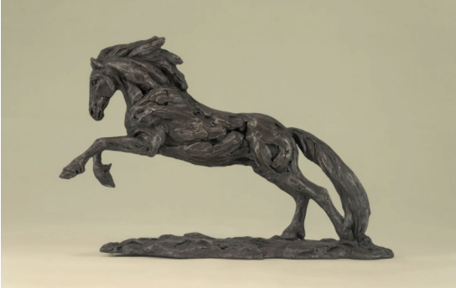

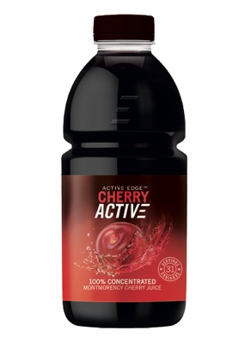
Wishing the best of luck to Penny Carey riding Llandian Lionheart (aka Jeff) and Dawn Garner riding Picture Perfect (aka Pimms)
Sponsored by
Cherry Active Drink of Active Edge

Cherry Active is an antioxidant-rich cherry juice that helps muscles recover after hard exercise, like endurance riding. Used by thousands of professional and everyday athletes to recover quickly with an antioxidant boost.
08451 705 705
www.active-edge.co.uk
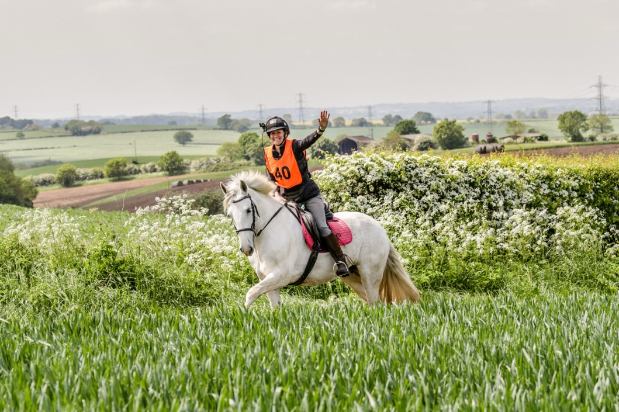
Dawn and Pimms at Foremark

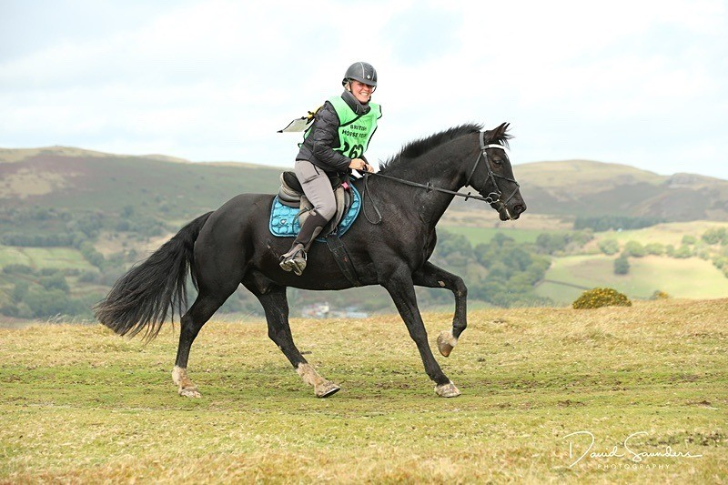

Penny and Jeff at Red Dragon
Photo by David Saunders Photography

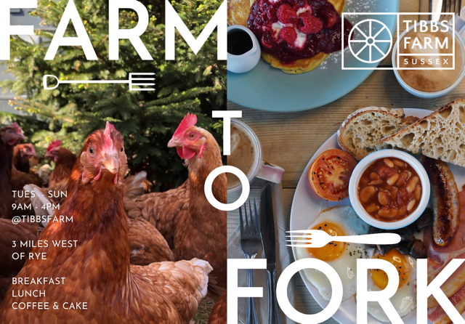

Gold Leaf Arabian Stud
Breeding Arabians for Ridden Performance since 1986
‘Good Luck to all our ‘GL’ owners competing in the
60th Anniversary Golden Horseshoe Ride 2025’
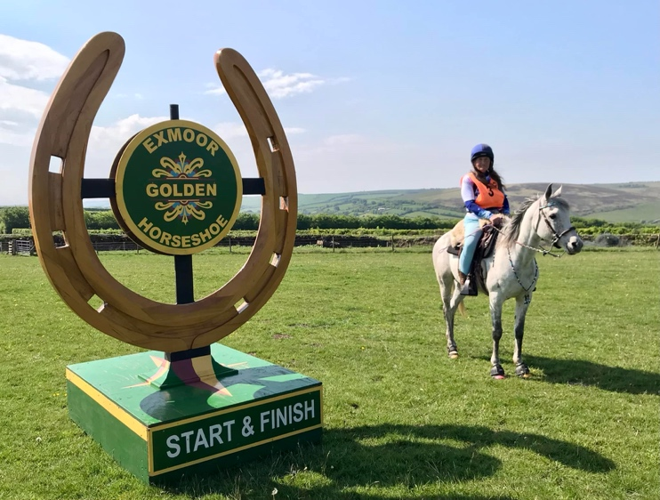
‘Prospective Endurance Arabians available for sale,
email- dawnbradbury82@yahoo.com
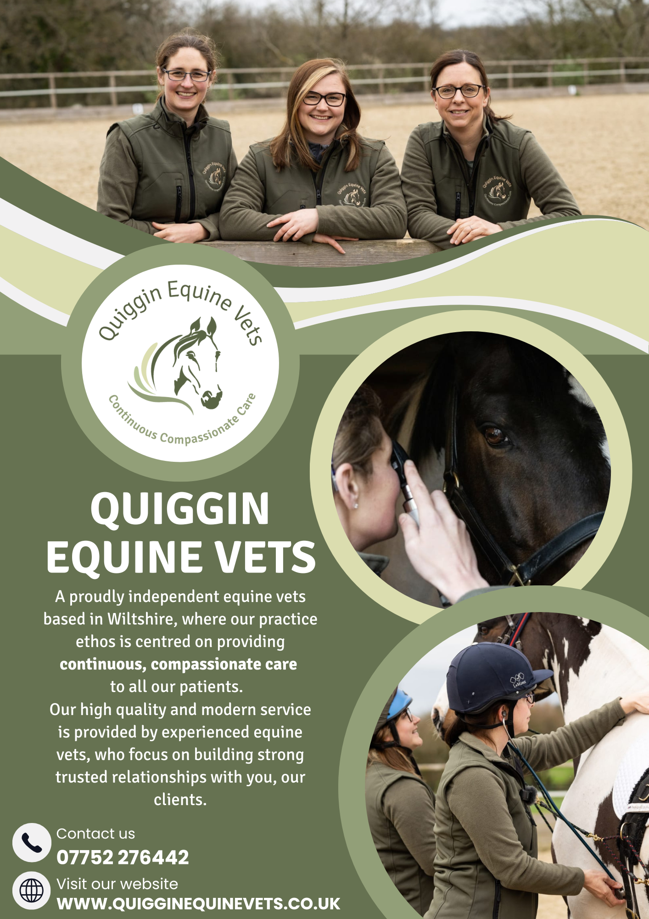

The 2025 Riders and Horses
The Golden Horseshoe – 80km / 1 Day / Linear
Bib No. | Rider | Horse
101 | Andrea Champ | Druimghigha Lantana
102 | Charlotte Robinson | Harepies Magic Mila
103 | Fiona Griffiths | Warrens Hill Caszidy
104 | Hollie Brewell | Cotswolds Shaquille
105 | Katy Mellor | Phoenix
106 | Maisie Denham | The Red Barron
107 | Mary Stubbs | Sachiya
108 | Melanie Bradley | Supermalc
109 | Nichola Pell | The Squire
110 | Philippa Verry | Charterlands Stilton
111 | Saffron Bishop | Ty Shute Golden Savannah
112 | Wendy Everson | Dizzy Miss Lizzy

The Exmoor Stag – 120km / 2 Days (80km Linear/40km Circular)
Bib No. | Rider | Horse
201 | Anja Brandt | Shaarif
202 | Caroline Cowley | Santa Ana Mist
203 | Chris Rendle | Druimghigha Larikn
204 | Francis Bakker | Tannasg Solar Flare
205 | Georgina Vaughan | Vlacq Journeyman
206 | Linda Cowperthwaite | Newberrys Ditto
207 | Susan Rossi | Wickwood Park Domino

The Golden Clench – 40km / 1 Day / Linear
Bib No. | Rider | Horse
211 | Amber Avery | Waditta (DK)
212 | Anita Gordon | Pele
213 | Carri Ann Dark | Toby 1 Khanobi
214 | Claire Barry | HS Alto
215 | Esther Groen | Watt Du Colombier
216 | Janet Kenward | SMJ Severianos Dream
217 | John Coldicott | Oliver
218 | Sally Farrall | Bashar Ibn Orion
219 | Susan Cox | HS Empathy
The Otter – 40km / 1 Day / Circular
Bib No. | Rider | Horse
10 | Abigail Chisholm | Strinesdale Mark
11 | Amie Grainger | Vlacq The Alchemist
12 | Angela Brewell | Masai
13 | Barbara Moorhouse | Taylor’s Flicka
P81 | Caroline Pitt | GL Gilded Lady
14 | Claire Barry | HS Alto
15 | Esther Groen | Watt Du Colombier
16 | Hayley Gilmore-Andrews | Art Mauresque
17 | Helen Newton | El Borann
18 | Jaime Snell-Pollendine | Hassmar de la Fichade
19 | Jan Prettejohn | The Graduate
20 | Janet Kenward | SMJ Severianos Dream
21 | Jessica Langham | Office Flirt
22 | Jim Phillips | Tannasg Sovereign
23 | John Coldicott | Oliver
24 | Jonathan Flook | Nabiil
25 | Julie Elvy | Stoneage Icon
26 | Justine Smiley-Jones | Sharky
27 | Kathy Carr | Tannasg Storm
28 | Katie Bedwin | Elayla
29 | Paul Simmons | Zayin Zachilles
30 | Rosie Martin | HS Dartagnon
31 | Sally Farrall | Bashar Ibn Orion
32 | Susan Cox | HS Empathy

The Otter Cub – 40km / 1 Day / Circular
Bib No. | Rider | Horse
50 | Alice Reeves | Dazzling Star
51 | Barbara Rees | HS Cymbaline
52 | Debrah Farrell | Inny Lady
53 | Fruzsina Molnar | Zakby
54 | Helen Pitt | Bomba
55 | Janthea Newman | GL The Enigma
56 | Justine Brett-Finch | Bellamina Dark Diamond
57 | Katrina Michael | MW Vallero
58 | Lenice Bell | Ithon Nero
59 | Martin Boreham | GL Haruki
60 | Megan Bevan | Gee Whizz
61 | Millie Harp | Solo Saxophone
62 | Rebecca Townsend | Vital Spirit
63 | Sue Box | Crystal Sultan
64 | Ylva Mowatt | Lady Goddiva

The Bambi – 25km Pleasure Ride
Bib No. | Rider | Horse
100 | Adele Bourne | Willow
101 | Amber Avery | Waditta (DK)
102 | Bella Fricker | Spanish Heir
103 | Beverley Kidman | Ashness Black Rupert
104 | Christine Nicholls | There She Is (Pancake)
105 | Dawn Garner | PR Picture
106 | Emilie Warren | White Rose Aurora
107 | Emily Hammond | Disney
108 | Emily Johns | Great Madoc
110 | Emma Miller | Chantylly Lace
111 | Greg Glendell | Magic Magnet
112 | Heather Cornick | Peshwari
P49 | Jane Atack | Crofthousefarm Baby Grace
114 | Jane Holdsworth | HS Cicero
115 | Jennifer Law | Pontoon Bridge Boy
116 | John Adams | Stunstead Muscovado
117 | Julian Johansen | CF Samuel
118 | Julie Dickens | Archways Lovada Annie
119 | Laura Draper | PHA Just Devine
120 | Leola Hammond | HB Pandora
121 | Margaretha Herman | Pioneerstud Gold N Psylk
122 | Mary Hannah | Kingsby Fennel
123 | Maxine Golledge | TD Moutahzen
124 | Nicola Routledge | Summers Place Michka
P8 | Olivia Cornick | Rhydfendigaid Glen 104620
125 | Paula Heather | JC’s Bailey
126 | Penny Carey | Llandian Lionheart (aka Jeff)
127 | Rhiannon Holman | Oakfield Katy
128 | Richard Golding | Midnight Constance
129 | Rosemary White | Nohilly’s Lad
130 | Sally Hall | Stirling Silver Hill
131 | Sue Wickenden | Tess
132 | Susan Holloway | Ardra Joe
133 | Susan Ragbourne | Abbeyward Lily
134 | Susanne Tucker | Slieve Croob JJ
135 | Vanessa Newman | Dior Des Lieux
136 | Vanessa Woodhouse | Broeurig Sparkle

The Fawn – 16 km Pleasure Ride
Bib No. | Rider | Horse
140 | Amanda Lang | Graigyfforest Jasmin
141 | Ann Maisel | Filada
142 | Hannah Lang | Chalky II
143 | Heidi Orrell | Sunny
144 | Helen Brophy | Emma
145 | Helen Brown | Polly
146 | Judith Yarnold | Oulartleigh Socks
147 | Marthe Kiley-Worthington | Druimghigha Shatish
148 | Maxine Cooper | Moorland Picture
149 | Rosie Brown | Mojito Boy
150 | Sian Grffiths | Barbara

We wish everyone of you the best of luck and hope you enjoy the trails!
Don’t forget you are trotting in the hoofprints of riders for 60 years before you!

The Horse

Where in this wide world can man
find nobility without pride,
friendship without envy, or beauty
without vanity?
Here where grace is laced with
muscle and strength by gentleness confined.

He serves without servility; he has fought
without enmity.
There is nothing so powerful, nothing less
violent;
there is nothing so quick, nothing more patient.

England’s past has been borne on his back.
All our history is in his industry.
We are his heirs; He is our inheritance.

Ronald Duncan
